Designing Effective Discussion Forums
Phase 1: Plan the Purpose
Notes:
Choose a Purpose
I want students to discuss the concept of war, to be able to discuss each major war, their causes, and their similarities and differences. I want students to analyze the role of propaganda in the nation’s responses to each war, and to consider what it would be like to be a soldier and a civilian during those difficult times.

Phase 2: Plan the Activity

Activity Levels
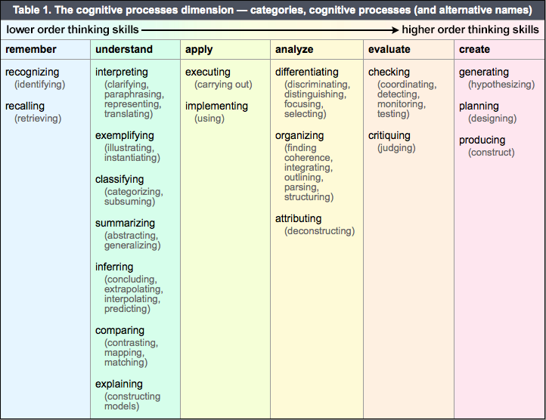
Each forum purpose has three corresponding activities from which to choose. The Key Concept, Community Building and Reflection categories are divided into Beginner Level, Intermediate Level and Advanced Level activities. The Critical Thinking category offers three Advanced Level activities due to the fact that thinking critically requires high level cognitive skills (as shown in the Overview table below).

Beginner Level – at this beginning level the student learns key terms and key concepts. Activities are basic, requiring low level thinking skills such as the ability to identify and classify information.
Intermediate Level – at this intermediate level the student learns to apply and analyze information. Activities require mid-level thinking skills such as the ability perform tasks and identify relationships between concepts.
Advanced Level – at this advanced level the student learns to synthesize information. Activities require high-level thinking skill such as the ability to evaluate and critique information. At this level, independent and original thinking occur.
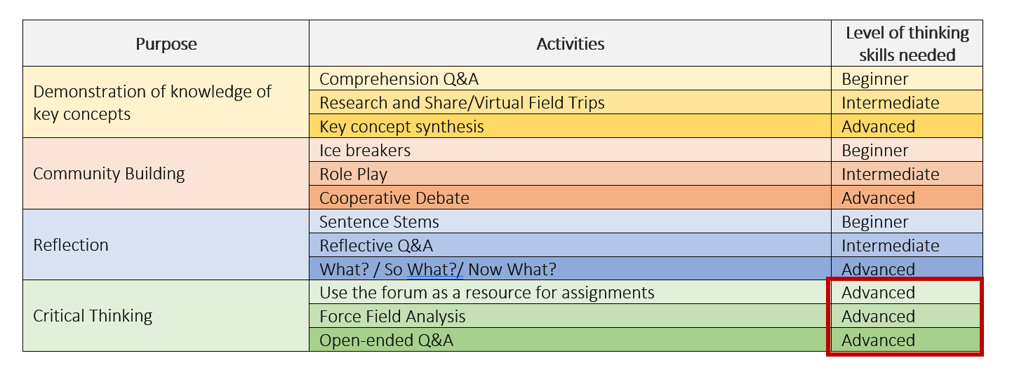
Forum Purposes and their Activities – Overview

Choose an Activity
I want students to discuss the concept of war, to be able to discuss each major war, their causes, and their similarities and differences. I want students to analyze the role of propaganda in the nation’s responses to each war, and to consider what it would be like to be a soldier and a civilian during those difficult times.

Phase 3: Choose the Forum Type

Most common

Bringing it All Together

See the Guide to Designing Instructional Discussion Forums by Chris Gonnella for more details.

